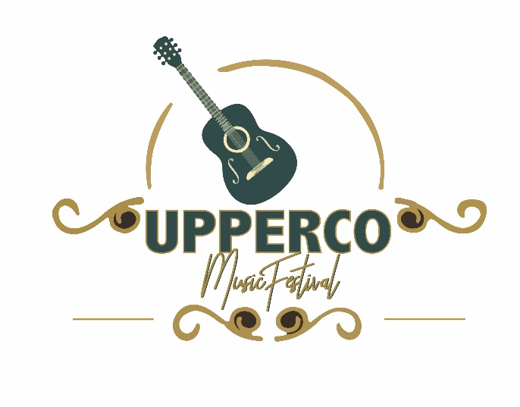
September 23-25, 2021
Upperco Music Festival
5415 Arcadia Ave.
Upperco, Md. 21155
Ph.410-491-2687 uppercomusicfestival@gmail.com

2021 Festival Instrumental Sponsors

$1000 Guitar
- Sponsorship announced ALL days from the stage
- Sponsorship on UVFC Website and Facebook Pages
- Vendor Space or Other Promotional opportunities optional
- Advertisement in 2021 Program – Your Logo
- Advertising on stage Banner
- 10 Weekend Passes

$500 Mandolin
- Sponsorship announced ALL days from the stage
- Sponsorship on UVFC Website and Facebook Pages
- Vendor Space or Other Promotional opportunities optional
- Advertisement in 2021 Program Book – Your Logo
- Advertising on stage Banner
- 4 Weekend Passes

$250 Banjo
- Sponsorship announced at ALL days from the stage
- Sponsorship on UVFC Website and Facebook Pages
- Listed in the Program
- 2 Weekend Passes

$100 Fiddle
- Sponsorship announced at ALL days from the stage
- Sponsorship on UVFC Website and Facebook Pages
- Listed in the Program
- Patron add in 2019 Program Book

$50 Bass
➢ Patron Add in 2021 Program

Monetary donations, gifts cards and other services will be considered a monetary donation for sponsorship recognition. For example, if you would like to donate gift card, raffle items, and or musical instruments to be awarded as a prize, you will receive recognition for that donation.
Please send your generous donations or make checks payable to the Upperco Volunteer Fire Company and return or contact Kenny Wise at (410) 491-2687.
ALL MONETARY DONATIONS ARE TAX DEDUCTABLE!!!!

